**Introduction to Payment Processing: -**

Used for transferring money and settlement among different banks, financial Institutions and customers.

Domestically, banks use clearing and RTGS (Real Time Grossing Settlement) and internationally use SWIFT network.

The Payment can be local/cross-border, single/multi-currency and will be by electronic fund transfer with/without Intermediary involvement.

The Initiating channel can be physical or electronic.

Electronic Modes of payment can be through Card, Mobile, electronic fund transfer etc.

**What is Clearing house?**

It is a financial institution that establishes and records obligations arising from the

transfer of value and ensures that they are settled according to the rules relevant to such transactions.

• A clearing house stands in between two clearing participants to reduce the risk of failure to honor the settlement responsibility by either or both participants.

• Clearing houses should be well managed and capitalized as it is taking the risk of

settlement failures into itself.

• For example, in US NACHA (National Automated Clearing House Association) arranges the mechanism for the financial service organizations that participate in the Automated Clearing House (ACH) network.

**Clearing and Settlement: -**

**Clearing: -**

In banking and finance, clearing denotes all activities from the time a commitment is made for a transaction until it is settled.

Processes included in clearing are reporting/monitoring, risk margining, netting of trades to single positions, tax handling, and failure handling

Most of the banks are member of clearing systems for transferring the money and settlement

Examples of clearing system: For US – FEDWIRE, CHIPS. For Europe: - STEP2, Target2 and so on.

**Settlement: -**

Settlement (of securities) is the transfer of funds / securities in order to fulfill the contractual obligations.

Settlement is facilitated by clearing processes such as netting and novation.

**Why Clearing is required?**

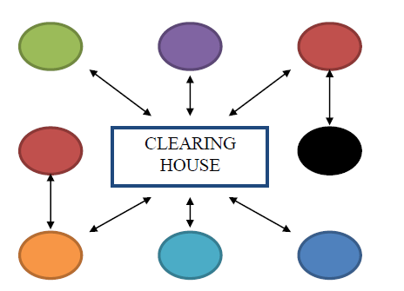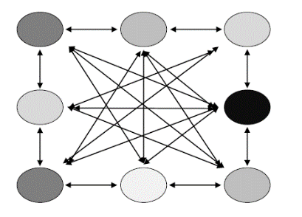

Each Bank/FI will have to maintain account Each Bank/FI just need to maintain an account

with the clearing house.

with all other banks.

**Funds Transfer Within the Particular Bank Branch: -**

Funds transfer between accounts within the same Branch is accomplished through a book entry. By debiting the Drawers account and crediting the payees account.

Example: There are two customers Mr. X and Mr. Y both have an account with I suppose State Bank of India at Kormangala Branch Bangalore. X’s Account number is 139693 and Y’s account number is 139729 and if Mr. X wants to transfer a sum of rupees INR 3000 from his account as a result X issues an instrument in favor of Mr. Y stating the instruction to bank of India to transfer the said funds

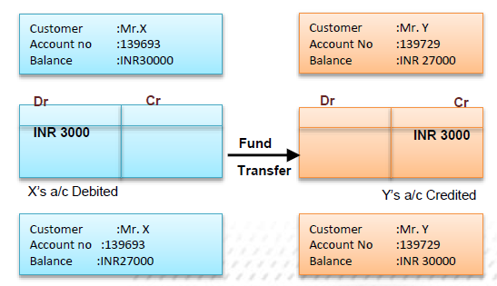

**Funds Transfer between two Banks**

**(Account relationship is present)**

Let’s say there are two banks and they maintain account with one another and customer from one bank needs to transfer funds to customer of another bank.



**Funds Transfer between two Banks**

**(Account relationship is not present)**



**NOSTRO / VOSTRO and Mirror accounts: -**

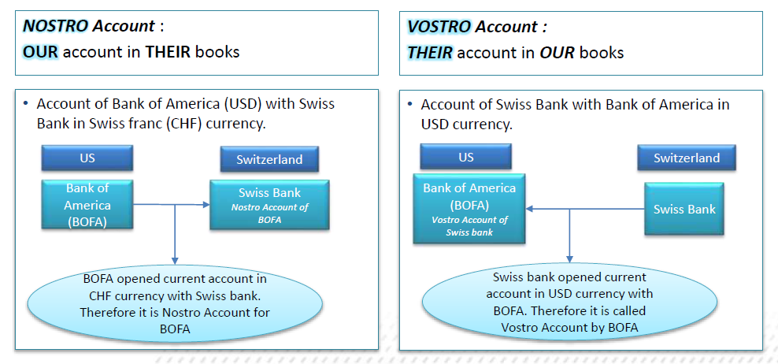

**Mirror Accounts: -**

• Generally for reconciliation purposes banks always maintain a mirror account of the actual account maintained with other banks.

• This helps them to keep a track of the account status.

• This means that if there is a Credit in the actual account for 100 USD than there will be a corresponding Debit in the Mirror account for 100 USD.

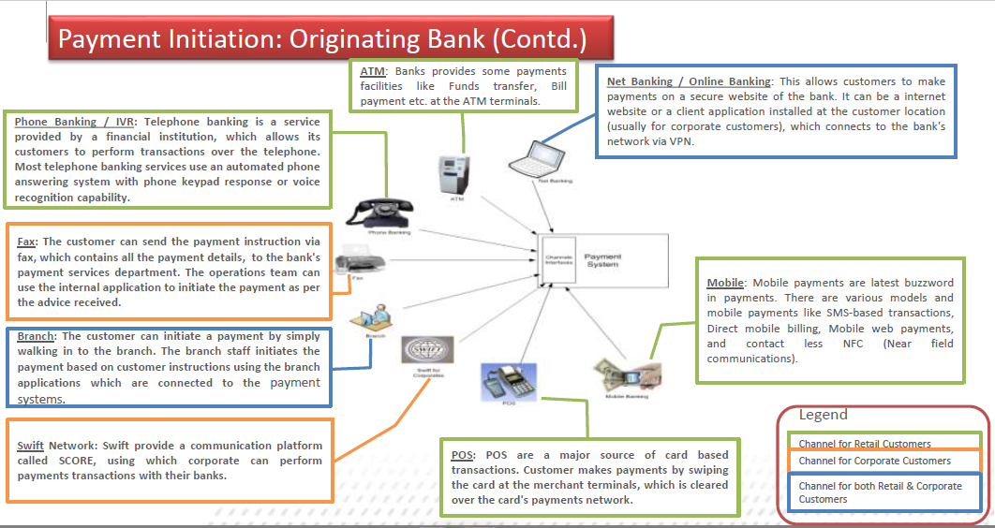

**High Value Payments: -**

High-care, Urgent payments.

• Can be Net or Gross settlement.

• Swift is one of the most commonly used medium for high value payment processing.

• More than 60 high-value clearing and settlement systems rely on SWIFT for the common message standards.

• There are Other proprietary based clearing as well which support high value processing (RTGS / NEFT in India).

**Mass Payments / Low Value Payments: -**

Low-care, non-urgent payments bulked together for efficiency.

• Settlement on ‘Net’ basis.

• Types of Mass payment messages.

• **Credit Transfers**: Single Debit and multiple credits scenario. E.g. Dividend payment by a company to its shareholders or Salary payment by an employer to its employees.

• **Direct Debits**: Single Credit and multiple debits scenario. E.g. Utility company like an electricity company collecting bills from its customers/users.

• Mass payments are also referred as ‘Bulk payments’.

**Electronic Clearing Service (ECS): -**

ECS is an electronic mode of payment / receipt for transactions that are repetitive and periodic in nature.

• ECS is used by institutions for making bulk payment of amounts towards distribution of dividend, interest, salary, pension, etc., or for bulk collection of amounts towards utilities like telephone, electricity dues etc., tax collections, loan installment repayments, periodic investments in mutual

funds, insurance premium etc. Essentially, ECS facilitates bulk transfer of monies from one bank account to many bank accounts or vice versa.

• The ECS is further divided into two types

-- **ECS (Credit)**: is used by an institution for affording credit to a large number of beneficiaries. E.g. amounts towards distribution of dividend, interest, salary, pension, etc., of the user institution.

-- **ECS (Debit**): ECS Debit is used by an institution for raising debits to a large number of accounts. ECS Debit is useful for payment of utilities, taxes or repayments which are periodic and repetitive.

**Deferred Net Settlement (DNS): -**

In DNS, the settlement takes place with all transactions received till the particular cut-off time.

• The beneficiary may get credit on the same Day or the next Day depending on the time of settlement.

• An example of DNS is NEFT which operates on a deferred net settlement basis which settles transactions in half hourly batches, there are twelve settlements from 8 am to 7 pm on week days and six settlements from 8 am to 1 pm on Saturdays.

**Real Time Gross Settlement(RTGS): -**

The acronym 'RTGS' stands for Real Time Gross Settlement, which can be defined as the continuous (real-time) settlement of funds transfers individually on an order by order basis (without netting). 'Real Time' means the processing of instructions at the time they are received rather than at some later time; 'Gross Settlement' means the settlement of funds transfer instructions occurs individually (on an instruction by instruction basis).

The RTGS system is primarily for large value transactions.

• The minimum amount to be remitted through RTGS is Rs.2 lakh . There is no upper ceiling for RTGS transaction.

• The payments are final and irrevocable.

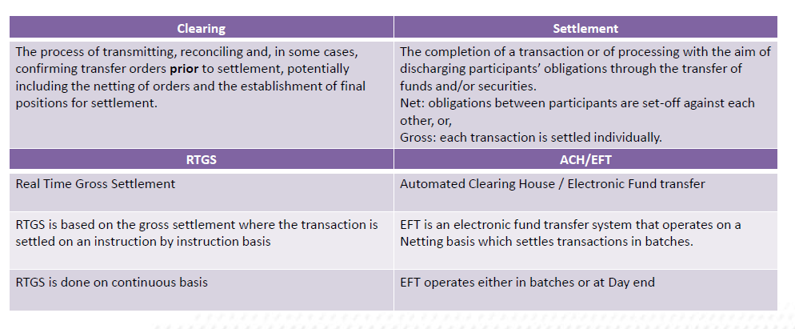

**Messaging: Basics**

A financial institution needs to exchange huge amount of data in the form of commercial instructions or requests, to operate their business.

• Such instructions will only work if the sender and receiver interprets this data in the way it is intended to be.

• And for this to happen there has to be a common understanding of these instructions among the parties.

• To satisfy this, the financial industry has created message definitions – that is, standards on how to establish and interpret the data they want to exchange in a standard and structured formats.

**SWIFT: -**

The Society for Worldwide Interbank Financial Telecommunication operates a worldwide financial messaging network which exchanges messages between banks and other financial institutions.

• SWIFT is a member-owned cooperative under Belgian law that provides the communications platform, products and services to connect over 10,000 banking organizations, securities institutions and corporate customers in more than 200 countries.

• The majority of international interbank messages use the SWIFT network and every financial institution has a unique 8/11-digit SWIFT code.

Eg. - ICICI BANK INDIA BOMBAY (ICIC IN BB)



The architecture of SWIFT provides an integrated store and forward mechanism along with some transaction management.

• SWIFT provides service in areas like securities, derivatives, trade services, payments and cash management.

• SWIFT is known for various features in the financial world like

✓ Secure and reliable network for exchange of financial information

✓ Set of syntax standards for financial messages which is used for transmission of message to SWIFTNET or any other system.

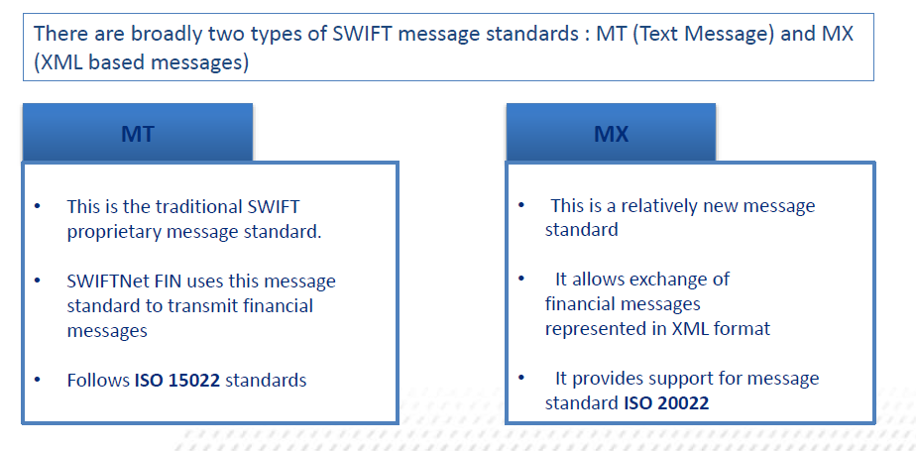

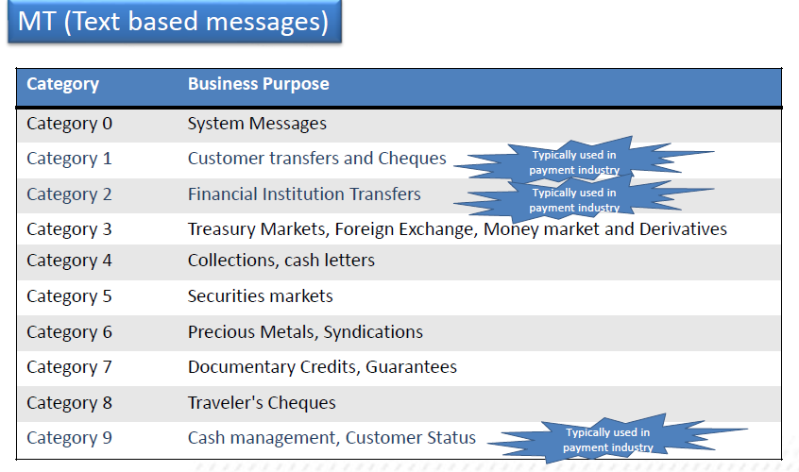

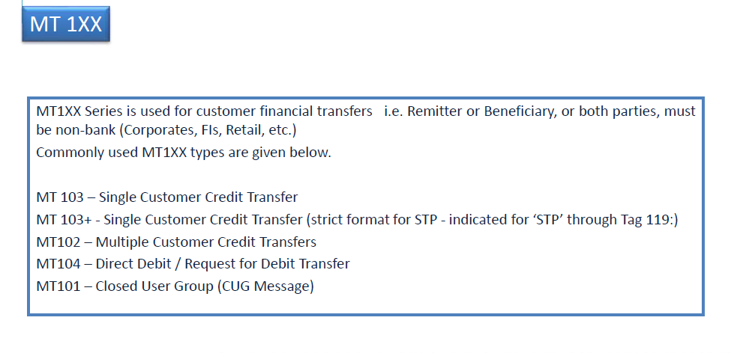

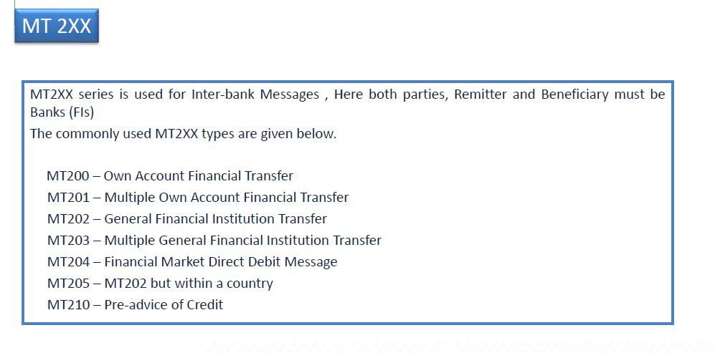

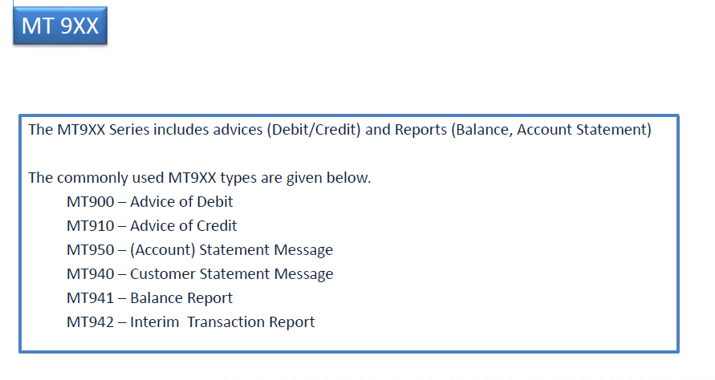

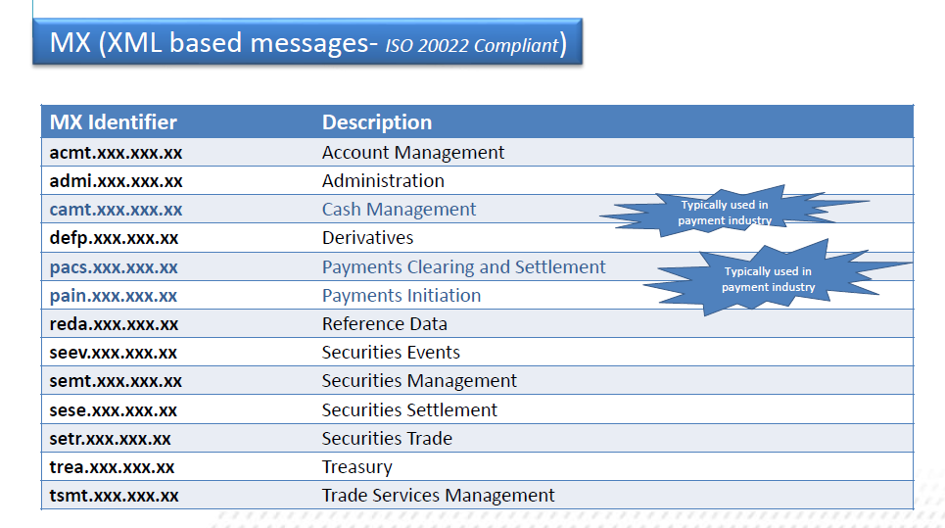

**Payment Systems of USA: -**

The Federal Reserve operates the following payment systems in USA

* Check services- The orthodox paper based clearing and settlement services. The electronic images as defined by Check 21 regulation are also settled and cleared through this mechanism.
* Automated Clearing House Services (ACH) - This is a mix and match of paper based and electronic instruments. The data based on the paper instruments is captured in an electronic format and the electronic details are transmitted to the settlement institutions.
* National settlement Services –This is a multilateral netting based on electronic files uploaded by the institutions.
* Fed wire Fund Services- This service is similar to the CHAPS of UK. This is also a Real Time Gross Settlement System.
* *In addition to the Federal Reserve ‘s payment system, there is one more popular payment system which is owned by banks and privately operated. This is popularly known as CHIPS (****C****learing* ***H****ouse* ***I****nterbank* ***P****ayment* ***S****ystems).*

**Electronic Payment Systems of Europe: -**

* **SEPA**

The origin of the Single Euro Payments Area (SEPA) is a direct outcome of the introduction of the new currency Euro. The geographical area covered under SEPA includes all the EU member states as well as Norway, Iceland, Liechtenstein, Switzerland and Monaco.

* **TARGET2**

(**T**rans-European **A**utomated **R**eal-Time **G**ross Settlement **E**xpress **T**ransfer) is the RTGS system used for Euro payments

* **EURO1**

The second settlement system is EURO1 operated by the **E**uro **B**anking **A**ssociation (EBA).

* **EBA Clearing**

In addition to handling EURO1, EBA also handles two other products viz. STEP1 and STEP2.

**Electronic Payment Systems of India: -**

* **Electronic Clearing Service (ECS):**

ECS is the short form for **E**lectronic **C**learing **S**ervice. The MICR technology was the predecessor for the ECS service.

* **National Electronic Clearing Service (NECS):**

NECS was introduced in 2008 and is a variant of ECS. The first difference is that the file can be given to a central location instead of giving the file to multiple locations. The second difference is that, if the bank is having core banking, there are no geographical restrictions on the account holder‘s branch. Thus, the NECS has a much wider reach compared with ECS.

* **RTGS:**

The acronym 'RTGS' stands for Real Time Gross Settlement, which can be defined as the continuous (real-time) settlement of fund transfers individually on an order by order basis (without netting). 'Real Time' means the processing of instructions at the time they are received, rather than at some later time.

* **NEFT**

NEFT (**N**ational **E**lectronic **F**unds **T**ransfer) is used for transaction value less than INR 200,000.

The core difference between NEFT and RTGS is that the former is settled on a deferred net settlement while the latter is always on a real time.